**Event Handler**

Just like dom we can use event handler in React here we use onClick, onChange,bind and so many things

**onChnage event handler:**

1st go to the component then create event handler folder and the here create a onClick.js file

Create a class using rcc command

And then write the code bellow

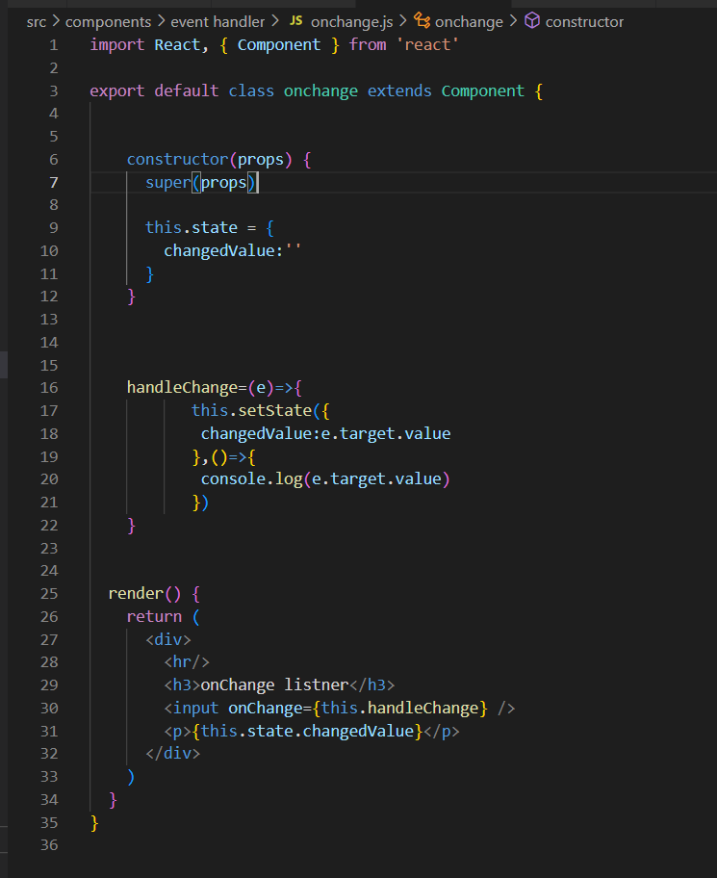

If u want to show value as well as it change then u must put the console log into this.setState()

5. Set the changedvalue as e.target.value

4. Create a function named handlechange

2. create a input tag and name the onChange function as handleChange

3.Then create a constructor

1.Create a onChange class

**bind:**

**Why we use bind?**

If we use arrow function in the onClick event handler then we don’t need to use bind but if we use normal function then we need to use bind.

That means ,

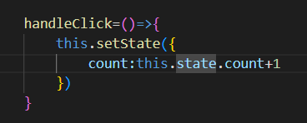

If we use arrow function then we don’t need to use bind.

But if we use normal function then the event handler might not work so that we need to use bind in the input tag or in the constructor

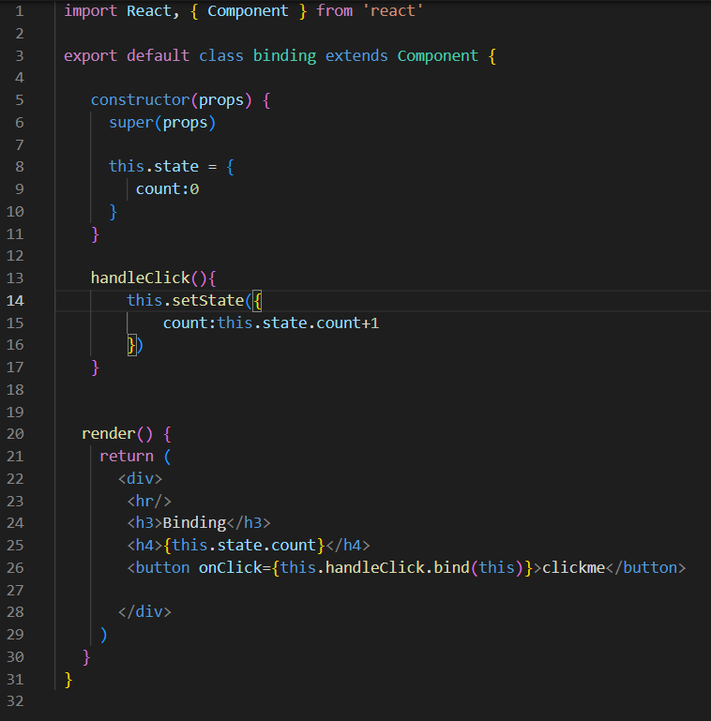

Here we use bind in our project when we use normal function

We can also use bind in the constructor and most of the we use bind in the constructor

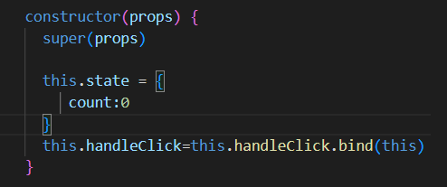

Here we use bind in the constructor and most of the case we use bind in the constructor